**Crafting Effective API Design with Node.js and Express**

[[](https://smit90.medium.com/?source=post_page-----65c2bb16845c--------------------------------)](https://smit90.medium.com/?source=post_page-----65c2bb16845c--------------------------------)

[Smit Patel](https://smit90.medium.com/?source=post_page-----65c2bb16845c--------------------------------)

·

Follow

5 min read

·

Aug 13

40

1

In the ever-evolving world of web development, crafting efficient and user-friendly APIs is crucial for building modern applications. Node.js and Express provide a powerful combination for creating APIs that not only perform well but also provide a smooth experience for developers and consumers alike. In this quick 5-minute read, we’ll delve into the principles of effective API design with Node.js and Express.

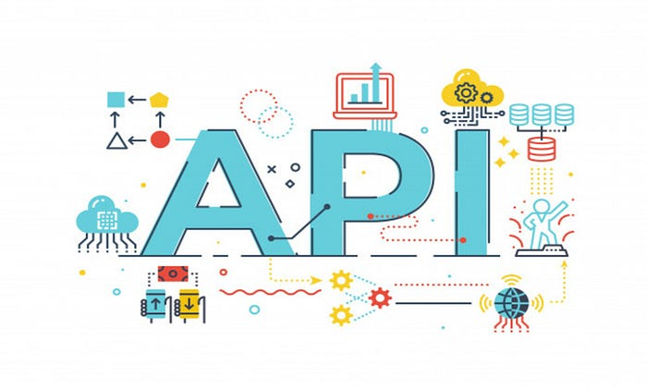

**1. Define Clear Endpoints and Resources 🗺️**

When designing an API, clarity is key. Clearly define your API endpoints, making them intuitive and easy to understand. Each endpoint should represent a specific resource or action, following a consistent naming convention.



// GET all users  
app.get('/users', (req, res) => {  
 // ...retrieve and send user data  
});  
  
// POST to create a new user  
app.post('/users', (req, res) => {  
 const newUser = req.body;  
 // ...create user and send response  
});

**2. Use HTTP Methods Effectively 🌐**

Use HTTP methods according to their intended purpose:

* GET: Retrieve data from the server.
* POST: Send data to the server to create a new resource.
* PUT: Update existing data on the server.
* DELETE: Remove data from the server.

// Using HTTP methods effectively  
app.get('/posts', (req, res) => {  
 // ...retrieve and send post data  
});  
  
app.post('/posts', (req, res) => {  
 const newPost = req.body;  
 // ...create post and send response  
});

**3. Embrace RESTful Principles 🌐**

Follow RESTful principles for consistency. Utilize appropriate HTTP status codes to indicate request outcomes:

* 200 OK: Successful GET request.
* 201 Created: Successful POST request.
* 204 No Content: Successful DELETE request.
* 400 Bad Request: Invalid request data.
* 404 Not Found: Resource not found.

// Embracing RESTful principles  
app.get('/products/:id', (req, res) => {  
 const productId = req.params.id;  
 // ...retrieve and send product data  
});

**4. Validate Input Data 📝**

Validate input data for data integrity and security. Express middleware libraries like express-validator help sanitize and validate incoming data.



// Using express-validator for input validation  
const { body, validationResult } = require('express-validator');  
  
app.post('/create', [  
 body('username').trim().isLength({ min: 3 }),  
 body('email').isEmail().normalizeEmail(),  
], (req, res) => {  
 const errors = validationResult(req);  
 if (!errors.isEmpty()) {  
 return res.status(400).json({ errors: errors.array() });  
 }  
 // ...create user and send response  
});

**5. Version Your APIs 🔄**

Maintain backward compatibility with versioned endpoints as your API evolves:

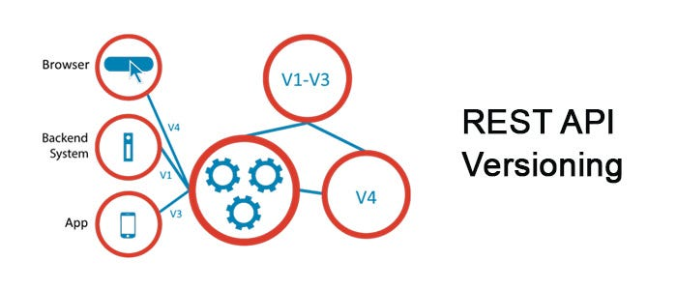

// Versioning your APIs  
app.get('/v1/users', (req, res) => {  
 // ...retrieve and send user data (version 1)  
});  
  
app.get('/v2/users', (req, res) => {  
 // ...retrieve and send updated user data (version 2)  
});

**6. Folder Structure and Design Patterns 🏗️**

Organize your project using a logical folder structure and design patterns like MVC (Model-View-Controller) to ensure modularity and scalability.

Example of Folder Structure:

- controllers/  
 - userController.js  
 - postController.js  
- models/  
 - User.js  
 - Post.js  
- routes/  
 - userRoutes.js  
 - postRoutes.js  
- app.js

**7. Error Handling and Middleware ⚠️**

Implement centralized error handling using middleware. Create custom error classes and use appropriate status codes.

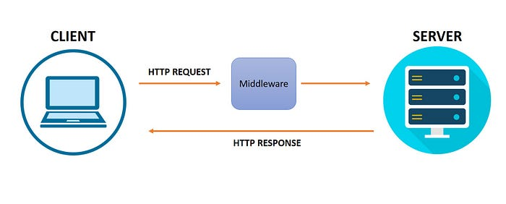

Example of Error Handling Middleware:

// Error handling middleware  
app.use((err, req, res, next) => {  
 console.error(err.stack);  
 res.status(500).json({ message: 'Something went wrong!' });  
});

**8. Implementing Logging Services 📝**

Enhance your API’s monitoring and debugging capabilities by implementing a logging service. Utilize libraries like winston or morgan to record important events, errors, and request details.

Example using morgan for request logging:

const morgan = require('morgan');  
app.use(morgan('combined')); // Logs detailed request information

**9. Handling Different Environments 🌍**

Adapt your API to different environments (development, staging, production) by using configuration files, environment variables, and logging levels.

// Handling different environments using environment variables  
const environment = process.env.NODE_ENV || 'development';  
  
if (environment === 'development') {  
 // Configure development-specific settings  
} else if (environment === 'production') {  
 // Configure production-specific settings  
}

**10. Automated Testing for Reliability 🧪**

Incorporate automated testing into your API development process. Write unit tests, integration tests, and end-to-end tests to verify the functionality of your API at various levels.

// Example of unit test using a testing library like Jest  
test('GET /users should return a list of users', async () => {  
 const response = await request(app).get('/users');  
 expect(response.status).toBe(200);  
 expect(response.body).toEqual(expect.arrayContaining([  
 { id: 1, name: 'John' },  
 { id: 2, name: 'Jane' },  
 ]));  
});

**11. Continuous Integration and Continuous Deployment (CI/CD) 🔄**

Integrate your testing suite into your CI/CD pipeline. Automate the process of testing, building, and deploying your API to different environments, ensuring consistency and reducing the chances of introducing bugs.

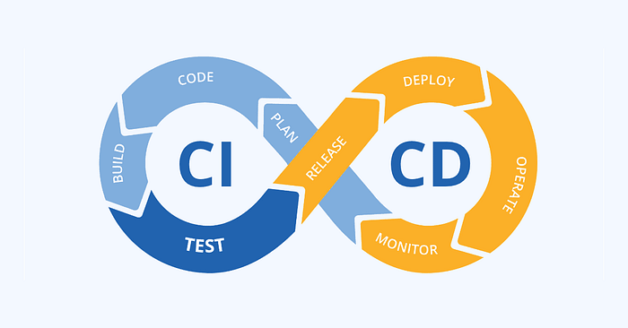

# Example configuration for a CI/CD pipeline  
stages:  
 - test  
 - build  
 - deploy  
  
test:  
 stage: test  
 script:  
 - npm install  
 - npm test  
  
build:  
 stage: build  
 script:  
 - npm install  
 - npm run build  
  
deploy:  
 stage: deploy  
 script:  
 - npm install  
 - npm run deploy

**12. Monitoring and Reporting 🔍**

Implement monitoring tools that track your API’s performance, uptime, and response times. Use services like New Relic or Prometheus to gain insights into your API’s behavior in real time.



// Example of setting up New Relic monitoring  
const newrelic = require('newrelic');

**13. Testing-Driven Development (TDD) Approach 🛠️**

Consider adopting a testing-driven development approach. Write tests before implementing features to ensure that your API functions as intended from the start.

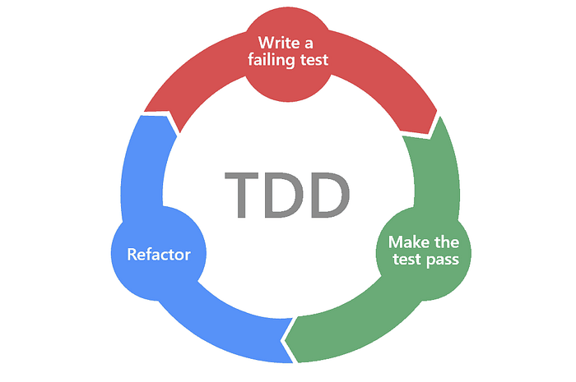

// Example of a TDD approach  
test('POST /users should create a new user', async () => {  
 const response = await request(app)  
 .post('/users')  
 .send({ name: 'Alice' });  
 expect(response.status).toBe(201);  
 expect(response.body.name).toBe('Alice');  
});

**Conclusion: Designing APIs for Success 🛠️**

Crafting effective APIs with Node.js and Express requires well-defined endpoints, RESTful principles, input validation, versioning, structured folders, robust error handling, and the application of design patterns. By following these principles, you’ll create APIs that are performant, developer-friendly, and user-centric. With your newfound knowledge, you’re well-equipped to embark on your journey of building robust and impactful APIs.

Remember, a well-designed API is the cornerstone of a successful web application. So go ahead, put these principles into practice, and watch your APIs flourish! 🎉